Profile of Sreelatha Menon

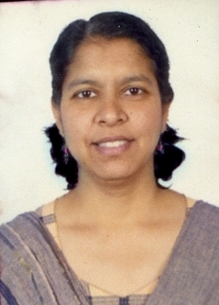
Sreelatha Menon, Editor Social Sector, Business Standard, Delhi.

I joined journalism as a sub editor in Indian Express in Kochi in 1988 December soon after my post graduation. I used to write on development issues off and on but later moved to reporting as a senior feature writer with Indian Express Delhi in 1997.

I have covered health and rural development issues as a correspondent there. I also won the Panos media fellowship for women's health.

I travelled to villages in UP in Ferozabad and Mainpuri during this fellowship and my objective was to see how much access women especially pregnant women had to health car ein rural areas. That was almost ten years ago.

I joined Business Standard in 2004 and have since been looking at various issues related to human development in the social sector.

I also look at NGOs as a sector and their role in development. A weekly column ear to the ground appears on Sundays and seeks to analyse issues in the social sector, whether it is NREGP or nutrition or education as perceived in the grassroots..

