PRADAN
A Brief Profile
By Soumen Biswas, Ex. Director

Introduction
We believe two conditions must be met, simultaneously, for poor people to break free from structural economic poverty. Firstly, their livelihood capabilities must be enhanced. Secondly, they must be able to find sustainable income earning opportunities. As a majority of poor people live in economically depressed regions, have no access to services and markets and are unorganized, such opportunities can be created on a large scale only through sectoral and/or area/ cluster development. This entails adaptation and extension of technology, creating reliable access to financial services and fair markets and to sustain livelihood gains, building institutions/ mechanisms over which poor people have control. Stimulating these changes requires knowledge and passionate, empathetic and long-term engagement.

It is such a construct of who the poor are and what needs to be done to enable them get out of their present condition to live a life of dignity and purpose that inspired the founding of PRADAN in 1983. PRADAN was founded on the belief that individuals with knowledge resources and empathy towards the marginalised must work with poor people if mass poverty is to be removed proactively. Knowledge is needed to expand the pie, as it were – expand opportunities for poor people through innovation and by adapting and demystifying technology, building and nurturing fair service linkages and beneficial networks, fostering collaboration among poor people and between them and the rest of the world and helping poor people enhance their capabilities. Empathy is essential if one is to spawn change in others’ lives by stimulating the latter’s resources. Development in that sense is a “helping occupation” where interest in and caring for the other are essential resources. This is particularly important when transactions are across inherently unequal players.

Broadly, these two themes – expanding livelihood opportunities for poor people and getting caring and capable people on board to do so – have guided PRADAN’s institution development processes all along.

Programs and Outreach
Following an area saturation approach, PRADAN currently (March 2009) works with 190,000 poor families in 43 districts across eight States in the poorest regions of the country. Women from about 90 percent of these families are organized into SHGs with an average membership of 14 each. Sectoral activities taken up to promote livelihoods include agriculture (cereals, vegetables and other cash crops, horticulture) supported by integrated development of land and water resources, livestock (dairy, goat rearing, fisheries), forest/ plantation-based activities (tasar and mulberry silk rearing, shellac rearing and leaf plate making), and rural enterprises (modern poultry, mushroom cultivation, tasar silk processing). These livelihood programs presently reach out to about half of the families. Typically, PRADAN has to extend support for three to five years, with declining intensity, before a poor family can carry forward the livelihood activity on its own. The extent and duration of support depends on how new the activity is to the people and the place, complexity of technology and linkages and the existential context of the household. For example, a tribal family would take longer to fully use newly created irrigation facilities compared to a traditional farming family; modern poultry takes intensive support for a long time compared to agriculture, etc.

Evolution of PRADAN’s Grassroots Programs
PRADAN began by placing its personnel in other NGOs working in villages on the assumption that they would be effective hosts to engage caring and capable professionals it had set out to draw into grassroots work. The experience was not very encouraging and in 1986 PRADAN also initiated its own village projects while keeping its commitments with NGOs. While the work with NGOs depended on their priorities and programs, the focus of our own projects was to increase poor people’s incomes. As a young group of maverick development workers PRADAN had little experience and strategies evolved largely from practice and reflection, such as SHGs to help poor women get access to credit, poultry and tasar sericulture as enterprises to enhance incomes of poor people, ‘5%’ and ‘thirty-forty’ models for in-situ rainwater harvesting to cope with drought, and ideas the founders brought on board from prior experience such as small scale irrigation and watershed development to intensify agriculture. By early 1990s, these had become PRADAN’s program ‘themes’, each implemented largely in isolation. PRADAN wound up its work with NGOs in 1992 as its own programs had grown and commitments with NGO partners had been fulfilled.

Geographic expansion occurred either through pilots to try out new ideas, such as in Kesla (M. P.), Godda (Jharkhand) and Madurai (Tamil Nadu) or when opportunities arose to collaborate with government programs to reach out to a large number of poor people. An example of the latter is an invitation in 1989 from the District Rural Development Agency in Ranchi which grew into a 10 year program to implement over 700 community micro-irrigation schemes in several Jharkhand districts, benefiting over 22,000 families by creating a gross command area of over 30,000 Ha, with about INR 175 m from various government programs leveraged to farmer groups. On a smaller scale, with support from respective governments, PRADAN revived Paals, a traditional water harvesting system in Rajasthan, rehabilitated traditional village tanks in Tamil NaduError: Reference source not found and implemented nearly two dozen small watershed projects under the National Watershed Development Program.

Picking up locally relevant ideas from each other, all project teams worked on multiple themes sans any integration across them. Being relevant everywhere, the SHG theme was common across all locations and by the late 1990s PRADAN had promoted a large number of SHGs, albeit confined to savings and microcredit. Similarly, watershed projects were cast in the traditional mould and did not go beyond conservation, irrigation projects did little for overall development of agriculture, etc. As outreach expanded the weaknesses of the thematic or sectoral approach, which had grown serendipitously, became apparent. Microcredit without livelihood development had limited impact as did irrigation without intensification of agriculture, soil and water conservation not rooted in livelihoods, etc. Since every village is not amenable to all or most of the themes, we had created scattered and disjointed outreach, with little synergy and low operating efficiency. Growth of the SHG ‘theme’ brought out these weaknesses most sharply as any attempt to help SHG members enhance livelihoods required multiple sectors or themes because resource endowments and interests of members varied even within a single group. Repeated critique of the thematic or sectoral approach in our internal reviews led to the development of the present “area saturation” approach in 1999. It was decided that PRADAN would work in ways to reach out to most poor people in the geographical area of operation of a project team, beginning with organization of poor women into SHGs. Promotion and nurturing of SHGs, thus, is no longer a standalone theme focused on microcredit; it is the first step towards livelihood promotion. Sectoral activities taken up by a team comprise a basket of livelihood avenues suitable for the families of SHG members in a geographical area, identified on the basis of people’s preference and local endowments. Similar critique has led to the evolution of INRM and non-farm enterprises as the key livelihood streams. INRM integrates activities that together enhance the present productivity and incomes as well as the future carrying capacity of the land and water resources poor people own or can access.

As livelihood coverage had lagged the overall outreach due to lack of integration between SHG promotion and sectoral work earlier, post 2001 there has been special emphasis on expanding sectoral coverage of SHGs. Process methodologies, such as visioning, livelihood planning, etc. were developed to help SHG members choose livelihood activities. At the same time, practice manuals, extension methodologies and training packages were developed to help staff scale up the outreach of matured livelihood prototypes, such as poultry, tasar, agriculture and now INRM. As a result livelihood outreach grew rapidly in the period 2003-2008. For example, outreach grew in poultry from 300 families to over 4,100 families, tasar yarn making grew from 250 families to 2,550 families, and tasar cocoon production grew from 1,800 to 6,200 families. During this period PRADAN has also been able to build on the earlier collaborations with the government at multiple levels to mobilise funds on a much larger scale. Between April 2004 and March 2007 we mobilised over INR 683 m for investment in livelihoods, including INR 285 m from governments. SHG savings rose by INR 81 m and they extended microcredit worth INR 188 m from own savings besides drawing bank loans. As economic activities by SHG members expanded the need arose to create sustainable mechanisms under their control to provide economic services, especially technical support, procurement and marketing. A number of producers’ organisations were set up to meet these needs around poultry, dairy, tasar processing and farming.

In a way, thus, the first few years were devoted to clarifying mission and strategy and saw a shift from an intermediary support organisation to a grassroots operating organisation. This was followed by a period of experimentation and trials and errors, culminating into a clear strategy and methodologies to promote rural livelihoods. The present outreach is largely an outcome of the past five odd years of focused attempts to scale out the successful pilots.

Leveraging Development Finances
Finances are needed to create livelihood assets and as working capital for poor families such as to construct a poultry shed, buy a dairy animal, raise plantations or buy feed and an seed; enhance productivity and carrying capacity of resources such as land development and construction of irrigation facilities; create service infrastructure such as a truck to transport inputs and produce, a milk chilling unit or a common work place; and build people’s skills and capabilities such as helping SHG members develop livelihood plans, exposing them to others like them who have grown new and better crops and training them in poultry, modern farming, running a cooperative, etc. PRADAN leverages such finances from government agencies at the district, state and federal levels, banks and people’s own resources, including savings by SHGs. About two-thirds of the SHGs promoted by PRADAN have been linked to commercial banks and leverage INR 100 to 150 m yearly as loans. As more and more producer organizations are being set up, credit is also being mobilized through those. The largest source of development finance, however, is the government at all levels. PRADAN is now able to mobilize development finances from these sources in the order of INR 500 m a year. As stated earlier, most of these funds are received directly by the people through SHGs and producer organizations and do not pass though PRADAN’s financial books.

Finances for Development Support Costs
Development support costs are the finances required to meet cost of staff engaged in grassroots work, field logistics, training of poor people, internal HRD, research and documentation and modest management costs and overheads. Most of these are mobilised from private trusts and foundations. While PRADAN has a large and diversified set of donors (there were more than 50 active grants in the past financial year), the largest contributors are the Bill and Melinda Gates Foundation, two largest Indian foundations, the Sir Ratan Tata Trust and Sir Dorabji Tata Trust, and the Dutch NGO, ICCO. The later three of them and the Ford Foundation, another long time donor, have also contributed to an endowment to partly finance PRADAN’s internal HRD costs. Increasingly, government programs are beginning to provide for a part of these costs, though the proportion is still small.

Internal Human Resource Development
As explained earlier, removing mass poverty among traditionally marginalised groups is a transformative process, leading to durable changes in their behaviour and the economic routines they engage in. While the latter is widely understood, acknowledged and attended to, the former generally is not. Consequently human resources developed for the sector are only equipped with cognitive abilities as economic routines essentially entail the use of technology and material exchanges. However, changes in perception and behaviour that must precede acceptance of changes in economic routines require social capabilities, including empathy to draw out poor people that springs from extension motivation – the urge to stimulate positive changes in the lives of others, investing oneself into others. Identifying and drawing such people, enabling them to uncover such motivation in self and nurturing it, and then enabling them to acquire the necessary social and technical skills has therefore been the core agenda of internal HRD in PRADAN, almost at the level of organisational mission.

As with its action programs, HRD strategies and processes too evolved over time in PRADAN even though the need for ‘special kind of people’ for development was a founding belief. In its early years, PRADAN drew personnel through word of mouth and gave them brief exposure to grassroots work through visits to other NGOs and later PRADAN’s own projects. Those who chose to stay would be placed in grassroots projects, to learn on the job. As the organization began to take shape and needed to recruit personnel in an assured way, a separate Human Resources Development (HRD) Unit was created in 1993 and HRD processes and programs began to be developed systematically.

The initial focus was on recruitment, induction and early training at the entry level. A multi-tiered recruitment process was designed, to be administered by field personnel in a highly decentralised way. This has been refined over the years and remains critical as an effective outreach and a discerning filter to bring in the “right” people to PRADAN. We now recruit from over 60 universities and institutes across the country. Some 55 experienced staff trained as recruiters visit the campuses, taking time off from their project work. They screen a film on PRADAN showing life and work in villages to young graduating students, conduct a written test, group discussions and a personal interview. An on-line, automated recruitment system also processes applications in selection camps held at five centres across the country.

A 12-month Development Apprenticeship was simultaneously designed for newly inducted university graduates. Refined over the years, it is the main mechanism to train university graduates as grassroots workers. An experienced, field based staff trained as a Field Guide mentors each Apprentice. The program gives an opportunity to young people for reality check – reflection inside for motivation, and exposure outside for opportunity – so that they can make an informed career choice, to join grassroots work or not. It also provides opportunity to learn some basic skills, knowledge and know-how needed for grassroots work.

PRADAN today brings in over 100 Development Apprentices a year, and 40 to 60 graduate as Executives. That all this happens in a highly decentralized way shows that the processes have been institutionalised – fully integrated into the working of PRADAN. The efficacy of the program may be seen from the following:
- 1,231 university graduates joined the apprenticeship during the past 15+years,
  - of these 530 joined during 2004-2009.
- 424 apprentices graduated as Executives in the past 15+ years,
  - of these 239 graduated during 2003-06.
- 52% of the graduating Executives between April, 2000 and March 2009 continue in PRADAN and another 24% continue in this sector after leaving PRADAN. Of these 5% who leave after 6+ years in PRADAN start their own organization and others played leadership roles in the organizations in the sector
- 52% of the graduating Executives between April, 2000 and March 2009 continue in PRADAN and another 24 % continue in this sector after leaving PRADAN. The percentages were similar in a survey conducted in 1999, for the period from 1991- 99.
- 39 % of PRADANites who joined work in villages during 2000-2009 left by 5th year of work for reasons related to life cycle stage
  - About half joined other organisations in the development sector, NGOs, banking and others
  - The other half went on for studies at the Masters level and business studies
- 81 PRADAN professionals have over 6 years' experience, and form its leadership pool. This was 60 in 2006 and 25 in 2000, and the growth is entirely attributable to the Apprenticeship program. In fact, all but a hand full are products of the Apprenticeship program.

Governance and Internal Organisation
The governance of PRADAN is vested in a Board of nine honorary members, who are persons of distinguished record in public service, two staff members nominated by the honorary members, and the Executive Director. The Governing Board renews itself by co-opting new members periodically as members can serve no more than two consecutive three-year terms. The Executive Director, appointed by the Governing Board is the ex officio Secretary of the Society and by convention serves a five-year term.

Field teams (currently 32), each headed by an experienced staff person designated as Team Leader and comprising of 6 to10 professional staff implement the livelihood promotion programs. Eleven senior staff members designated Program Directors support several teams each and/or have organisation-wide functional responsibilities, namely, HRD, Finance, Operations and Knowledge Management as members of a Management Committee, assist the Executive Director in policy and institutional development. Presently there are 257 professional staff, over a fourth of them with over seven years’ grassroots experience, trained in reputed universities in India and abroad in technology, management, agriculture, social and life sciences and humanities. Another 88 staff provide office and logistics support and about 150 short term contractual staff provide technical and logistic assistance in field operations.
Profile of Soumen Biswas

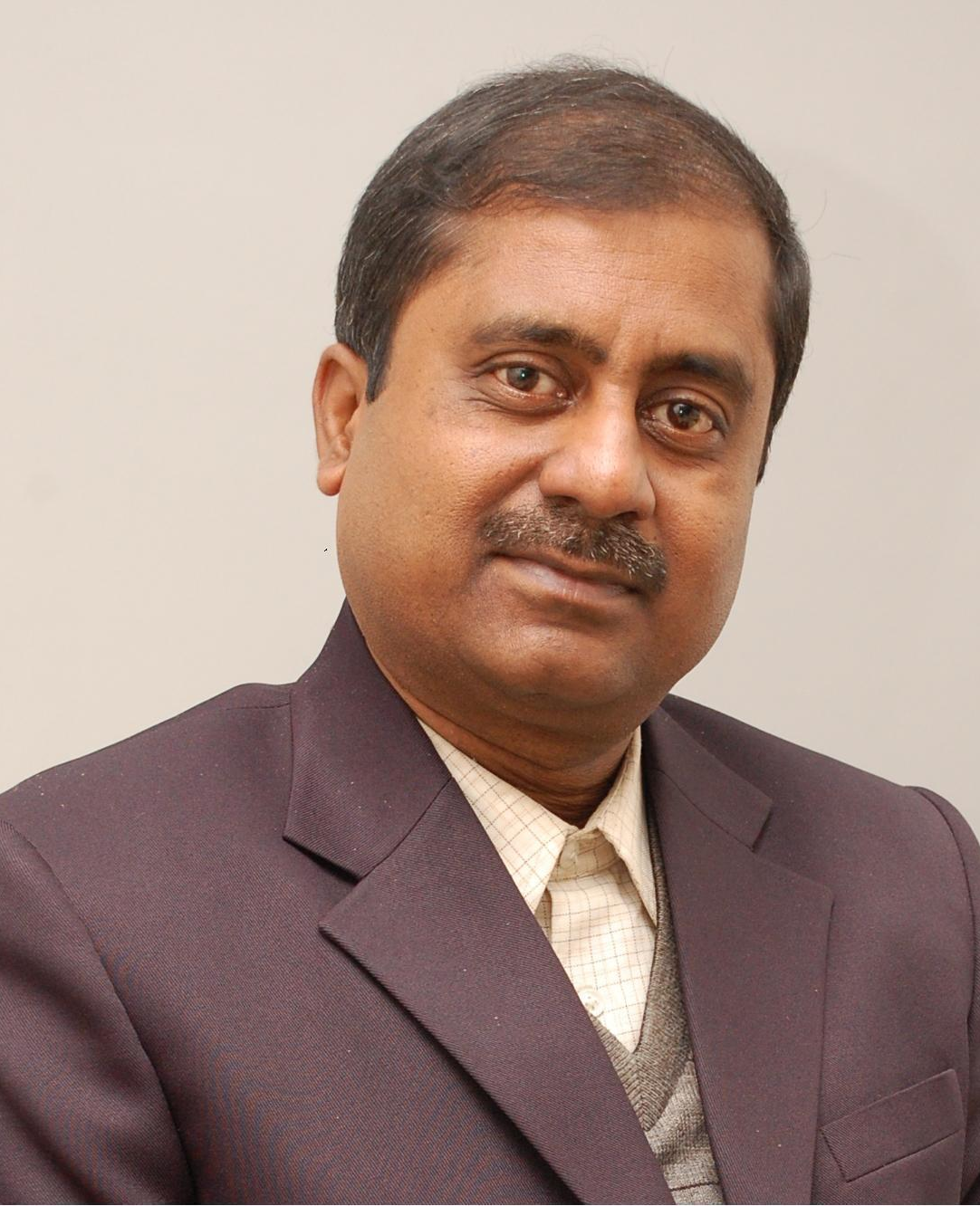
Mr Soumen Biswas is the Executive Director of PRADAN.

PRADAN (www.pradan.net) is a public service organisation with the mission “Impacting livelihoods to enable rural communities”. It works with the marginalized communities in the endemically poor regions of India. PRADAN was founded in 1983 on the belief that individuals with knowledge resources and empathy towards the marginalised must work with poor people if mass poverty is to be removed proactively. Broadly, these two themes – expanding livelihood opportunities for poor people and getting caring and capable people on board to do so – have guided PRADAN’s institution development processes since its initiation. PRADAN today is a leader in promoting rural livelihoods in both farm and non-farm sectors in India. It pioneered the self-help group (SHG) model to organise poor women to access mainstream financial services, has introduced new methodologies for grassroots action, developed robust prototypes of rural enterprises suitable for poor households in farm and non-farm sectors and successfully linked poor people to urban markets.

Soumen joined PRADAN in 1987 in the initial phase of his professional career, grew with the organisation and participated in its institution building processes. He set up a team of professionals to promote livelihoods for indigenous communities; experimented with and piloted initiatives to create new livelihood prototypes for the poor having widespread replication potential. Subsequently, he guided and supervised several PRADAN teams of professionals, spearheaded PRADAN’s human resource development initiatives and participated in developing organisational systems and processes. He has also engaged with a number of State Governments and the Government of India to improve poverty alleviation programmes. As the Executive Director, Soumen leads the organisation to its Mission. He anchors its institution building, fund raising, statutory compliance processes and spreads goodwill for PRADAN in the world.

Aged 48 years, Soumen holds degrees in Agricultural Sciences and Management. He is married to Madhumita who is a professional vocal musician. They live in New Delhi with their daughter.

The registered office of PRADAN is at 3 Community Shopping Centre, Nitibagh, New Delhi 110049
As a Charity, incorporated in the then Union Territory of Delhi under the Societies Registration Act (Act XXI of 1860).
The social composition is 51% tribal people, 15% dalits, 30% other “backward castes”, 4% other poor communities.
Assam, Bihar, Chhattisgarh, Jharkhand, M. P, Orissa, Rajasthan and West Bengal.
The phrase “livelihoods” had not yet become popular in the development lexicon.
PRADAN and MYRADA (in south India) were the first to promote SHGs for savings and microcredit in India, which later became the main microcredit model for banks when the Reserve Bank of India approved it in 1992.
These are success stories of pilots that involved much trial and error over several years.
Innovations by Dinabandhu Karmakar (with no experience) in search of ways to help farmers cope with a moody monsoon.
The term included both sectors, such as tasar and irrigation, as well as vectors, such as SHGs and watershed development. SHG, Tasar Silk Rearing, Small Scale (mainly lift) Irrigation, Microenterprises (poultry, mushroom cultivation and tasar silk processing) and Rain-fed Farming (then mainly watershed development and rainwater harvesting) were the themes.
Spun off into a new entity, the DHAN Foundation in 1997.
Factoring local administrative boundaries (Panchayats, Blocks and Districts), this is determined on the twin premises that staff should not have to travel more than 25 to 30 km to reach project villages assigned to them, and though based at two to three places within this area, they should easily be able to meet as a group periodically.
13 Co-operatives, 1 State federation of poultry Co-ops, 1 Producer Company for tasar have been set up.
PRADAN leveraged approximately INR 450 m for livelihood investments and consumption credit, including INR 191.6 m from Government, INR 85.6 m from banks, INR 113 m from SHG savings, INR 41.4 m people’s contribution and INR 16.2 m from donors during 2006-07. Also, INR 11 m was leveraged for training and handholding of project families.
Beliefs are changing on this score due to persistently poor performance of poverty alleviation programs, demonstration by NGO initiatives, writings of philosopher-academics like Amartya Sen who has given currency to the notion that being capabilities are distinct from doing capabilities, writings of activist-academics like Kancha Iliah who speaks passionately of the impact of social conditioning on one’s view of oneself and the literature on gender with similar conclusions.
A baccalaureate in technical disciplines and a master’s in others, typically amounting to 16 years’ education in India.
Do I really want to do this? Would I be able to cope?
Why must I do it? What does it all add up to?
Besides 83 development apprentices on board as on 30th September 2009.

