Corporate NGO Community Partnership For
Integrated Natural Resource Management Project

About Chemicals Business
Established in 1989, SRF Chemicals Business is engaged in manufacture and marketing of Refrigerant Gases and Speciality Chemicals for Pharma and Agro based industries. The plant is located in village Jhiwana in Tijara Tehsil of Alwar, Rajasthan.

SRF Chemicals Business is the market leader in the domestic refrigerant gases business with almost 40% market share, while exporting 70% of its production to over 55 countries around the globe.

The company has been actively involved in social projects for sustainable development in the villages around its factory. As part of its corporate social responsibility, it has focussed its efforts in the areas of Natural Resource Management, HIV AIDS awareness and primary education.

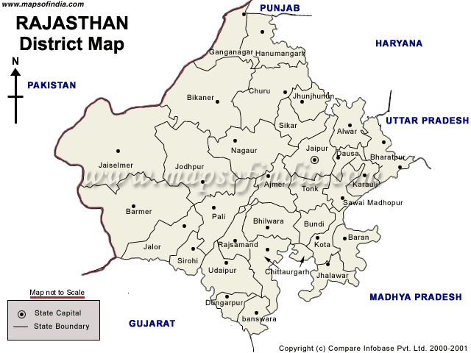
The Integrated Natural Resource Management (watershed) Project and Sustainable Environment Conservation in Alwar, Rajasthan
Tijara
The Integrated Natural Resource Management (watershed) initiative has been taken up since 2006-07 in 17 villages in collaboration with the NGOs PRADAN and Sir Syed Trust (SST) for livelihood improvement & environmental and ecological conservation in the highly degraded ecosystem of Aravali hills in Rajasthan.

The villages and model for intervention have been the result of a feasibility study in 35 villages taken up by the PRADAN team during 2006-07.

Introduction to the Project Area
Tijara is one of the blocks of district Alwar in Rajasthan. The Aravalli hills, one of the oldest fold mountains, is spread over 500 kms across N-E to S-W of Rajasthan. The Aravallis were covered by dense forest in the past. The increasing pressure of human and livestock population has taken a heavy toll of the vegetation resulting in severe land degradation with concomitant adverse environmental effects. This has adversely affected the quality of life of the inhabitants in region of Haryana and interspersed area of Rajasthan. Aravalli foothills are presently facing water crisis in view of large scale extraction of ground water by ever increasing number of shallow centrifugal pumps. In view of proximity to national capital region, farmers shifted to vegetable growing which need larger number of irrigations and exploiting the under ground water reserves. Though, sprinkler irrigation has become popular yet the extraction rates are much higher than groundwater recharge. Village ponds are drying up; hand pumps on which human and livestock depend have started yielding less and less water. Water crisis are looming large. Deep tube wells and submersible motors when installed by farmers have resulted in further lowering of water in adjoining shallow tube wells.

The selected villages for intervention under the pilot project are amongst the poorest and most backward in Tijara. Sex ratio, female literacy rate, over all literacy rates, are all indicative of the poverty in the villages. Meo Muslims and Dalits are the main communities in the villages.

Social- Economic Profile (*Source census data 2001)
Parameter | Alwar | Tijara | Villages (Phase 1)
Villages (Number) | 1,934 | 212 | 17
Population (000) | 2,992 | 280 | 18
SC/ ST (%) | 26 | 13.8 | 12.9
BPL (Number) | NA | 18,098 | 688
Literacy % | 49.7 | 45.26 | 32.89
Female Literacy % | 34.9 | 29.38 | 27.96
Sex Ratio (Females per 1000 Males) | 886 | 829 | 818

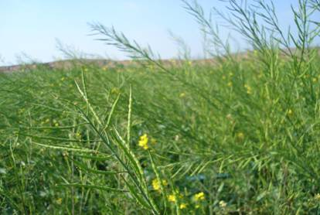
The Project
The Project is about improving livelihoods of the poorest by harnessing underutilized land and water resources.

The project involves formation of community based Self Help Groups (SHGs) and User Groups; these groups undertake construction of water harvesting structures like earthen check dams (paals), loose stone based check dams to harvest rain water which would otherwise flow off. In the catchment area of the earthen check dams, where the land is extremely undulated, terracing, land levelling and field bunding is done to make these wastelands cultivable. On these levelled lands various agriculture based livelihood activities are taken up.

Overall, SRF aims at developing Natural Resources in the carefully selected 50-60 villages of the block adopting an Integrated Natural Resource Management approach. This project aims to benefit approximately 6500 families, a majority of whom are from marginal and backward communities.

Setting up of grass-root level organizations

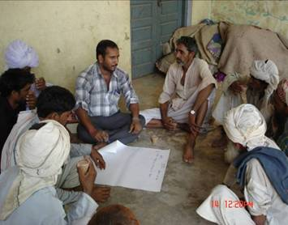
Promotion of community groups like SHGs, users groups, and producers groups form the primary activity of the project.

Self Help Groups: Groups have been formed and groomed and linked with banks for mobilizing credit for meeting emergency and other credit requirements.

User Groups: User groups are groups of 5-7 families whose undulated lands are falling in a contiguous patch. A user group could also be formed around large water harvesting structures by involving direct stakeholders.

Cooperatives/Producer Companies: Two cooperatives—one for goat and the other for agri-horticultural produce—are formed

Community contribution: Contribution from community is around 10-20 % under various interventions.
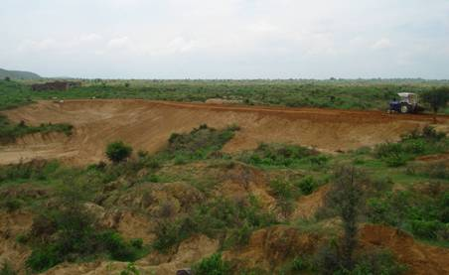
Water Harvesting

- The construction/repair of paals harvests rainwater, checks soil erosion and brings stabilization in the catchments area.

- Checking the speed of water by creating obstacles like loose stone check dams (LSCD) and paals at different places in the drains not only harvests the rainwater but also arrests silt along with organic matter that comes with water from the hills adding fertility to the soil in the fields. The water harvested gets opportunity time for downward movement thus recharging the groundwater of the area significantly.
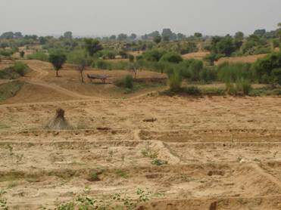
- Another strategy is to harvest rainwater in-situ (where it falls). Levelling of the field that has less than 5% slop combined with field bunding has been extremely effective. Large-scale field bunding of this land is helpful in maintaining fertility and retaining moisture in the fields.

- Land in the foothills that has a ravenous landscape requires special attention particularly in those cases where land is owned by the community but lies unutilized. Terracing of these lands with plantations along the contours helps farmers to earn significant incomes from these lands and also regenerate them over a few years.

Agri-Horticulture Development
Here the focus is on developing a model where every inch of the plot is used to its full potential. Crops are planned to be cultivated round the year. Three set of crops i.e., short duration (vegetable-regular crops), medium duration and long duration crops are planned. The model includes plantation of fruit plants in between and timber or fodder plants on the periphery of the plots.

Plantation combined with vegetable cultivation and crop interventions is promoted for maximizing per unit income from a plot (one Bigha). 300-400 fodder/timber plant saplings are planted on the borders of each field (averaging 400 plants per Ha). In the middle of the plots, if farmers are interested, 40-60 fruit plants (per bigha) are planted keeping the distance technically specified and also keeping future prospects of promoting vegetable cultivation and other crops in mind (the average comes to about 150-200 fruit plants per Ha).

Species selection
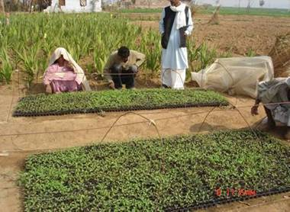
Fodder/Timber plants: In fodder and timber plants, the emphasis is on fast growing fodder plants like Ardu neem along with Desi neem, Sheesham and Jatropha.
Fruit plants: Emphasis has been on Amla, Lemon and Ber. A few new species like Mango, Kathal and Mosambi along with some others are being tried to check the feasibility (growth, survival, liking etc) of these plants in the area.

Progress So Far
Since 2006-07, we have been able to create:
- 119 Check Dams (Paals)
- 551 Loose Stone Check Dams
- Installed Injection wells & Piezometers for improved efficacy for Ground Water Recharge under guidance from CGWB, Jaipur
- Leveled 477 hectares of undulated Waste Land
- Planted 120,000 fruits, fodder and timber trees in the leveled lands
- Formed 66 Community Self Help Groups
- Introduced improved variety of mustard (T-59) with a yield of 32 Qt/ Ha against the local breed (yield 19 Qt/Ha)
- Introduced improved Agriculture practices in more than 350 acres in 2008-09 and 2009-10 impacting over 500 families

Impact Assessment:
It’s imperative to conduct an impact assessment to understand the benefits accrued/ likely to accrue in terms of the ground water recharge, growth and bio-physical impacts of the various project interventions as well as the socio-economic impacts on the community. SRF has therefore engaged another agency (SPACE) for independently undertaking an impact assessment of the various project interventions.

Corporate-NGO-Community Partnership Model
The project is one of the first endeavours of a Corporate-NGO-Community collaboration to take up development programs in Rajasthan. This project aims to be efficient, transparent, focusing equally on good processes and delivery, which would make the replicability of the project very much feasible in other parts of the country. The success of the project would also open the gates for other Corporate –NGO collaborative projects which would speed up the development process in the rural areas.

Families impacted
- 3780 families in 33 villages
Our Vision for NRM Based Livelihood Project
Management of Land, Water – Paals, Field Bunds, Plantations etc
Transforming farms– Enhanced Productivity
Social Transformation
60 SHG
&
Federation
Producer Companies

Milk Producers
Bank
Market
Producer Companies

Vegetable/Fruits producers
Mother Dairy
Empowered women, families
(Socially + Economically)
Mobilizing Women
30 Villages
Physical Work
Linkages established
Linkages established
Linkages established
Completion

SRF envisions that by the 5th year of the project, by virtue of the large scale plantations, the production of various fruits would be to the tune of 1500 tones. Handling of such large production would require a few secondary level of institutions, which would take up marketing of these commodities.
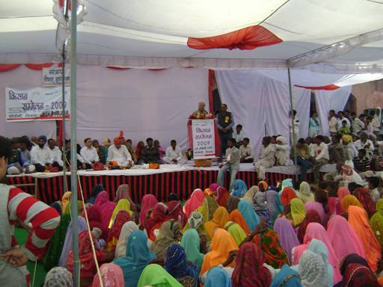
Besides this, for ensuring lucrative and constant returns to the farmers, Producers’ Co-operatives / Producers’ Companies would be formed. All beneficiaries of horticulture at the regional / cluster level would be the primary members of the co-operative. The co-operative would take care of price fluctuations for raw fruit in the open market and also market the produce of the members.

Kissan Sammelan

A Kissan Sammelan was organized in Feb 2009 with the following objectives:
- To acknowledge community for their work in paals construction, land leveling, plantation etc
- Hand over the paals to the community so that they take ownership of maintaining them as their own assets.

The event had participation of more than 1000 people, largely women.

Way Forward
Through this project, SRF has been able to:
- Effectively use Water as the starting plank for engaging local community
- Create livelihood opportunities for the poorest- through underutilized land & water resources
- Revive/Construct long term potential for rain water Harvesting
- Forge a unique Corporate- NGO Partnership Model for project implementation and Impact assessment
Obtain technical inputs from CGWB Jaipur to improve the efficacy of rain water harvesting structures.

SRF intends to leverage the benefits of partnership to further strengthen and scale-up its Integrated Natural Resource Management project in the coming years.

Contact Persons:

H S Dua
Associate Vice President – HR & CSR
SRF Chemicals Business
Sector 45, Block C, Gurgaon
Email: hsdua@srf.com

Ritesh Sinha
Manager – CSR
SRF Chemicals Business
Sector 45, Block C, Gurgaon
Email:
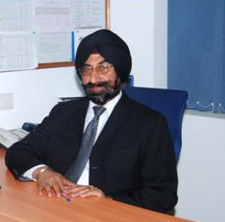
H S Dua
Associate Vice President HR and CSR
SRF Chemicals Business

HS Dua has worked in various capacities in SRF Group during the past 28 years. He started his career in Head office in 1982 and then moved on to SRF Nippondenso Ltd in 1989 to look after Industrial Relations. SRF ND was an associate company of SRF in those days. In 1993, he moved on to SRF Chemicals Business in Bhiwadi in Rajasthan where he has been continuing to look after HR, Industrial Relations and Community Relations. In 1995-96, when SRF acquired the Tyre Cord Unit from RPG group at Malanpur near Gwalior, he was deputed there for three years from 1997 to 2000 for integration of HR policies and practices.

HS Dua has been leading various social development initiatives for SRF Chemicals Business in Rajasthan and has contributed for improvement in quality of life of the poorest of the poor in the local communities around its factory. He has done this leveraging the competencies of the NGO partners associated with SRF Chemicals Business namely PRADAN, Sir Syed Trust, SPACE and Society for All Round Development (SARD).

HS Dua is a qualified assessor for CII Sustainability Awards and has also led this effort for his business resulting in SRF Chemicals Business winning the CII ITC Sustainability Awards in 2008 and 2009, two years in succession.

