AFPRO (Action for Food Production), New Delhi
“Evolving partnerships in changing context”

- Evolution of AFPRO
1.1 AFPRO (Action for Food Production) was formed at a period in time (history) when India was facing one of the worst food problems and crises like drought and famine in some of the heavily populated, backward and poverty stricken states of the country. The phrase commonly used was “From Ship to Mouth” i.e unless the imported and gifted food arrived in Indian ports and immediately reached to most needy areas/regions, the poor people would starve. At that situation relief was primary need of the hour. Apart from feeding the hungry, the wide-spread consecutive drought was posing the major challenge for the Government and Charitable institutions. The idea of formation of AFPRO has influence of the call given by the Food and Agriculture Organisation (FAO), of United Nations for starting Freedom from Hunger Campaign (FFHC), leading towards self sufficiency.

  - AFPRO was perhaps the first expression of the two groups of Churches namely Roman Catholic Churches (in response to the II Vatican Council) and World Council of Churches (WCC), Geneva – common thinking and conception of ecumenical effort for development. On the Catholic side the three agencies namely; Indo German Social Service Society (IGSSS), Indian Social Institute (ISI) and Catholic Charities – India (CCI), now know as CARITAS – India, were established to undertake of training, coordinating, appraising project proposals, funding, monitoring and formulating projects. They also had to handle import clearance for gift articles and equipments, their storage and distribution. The National Christian Council of India (NCCI) of the Protestant Churches establishes a Committee on Relief and Gift Supplies (CORAGS) to coordinate activities at national level.
  - As social action group they – CORAGS, IGSSS, ISI and CARITAS India soon realize the need for technical support and guidance mainly in the areas of food production and health. Process of formation of AFPRO indicates that it was not set up hurriedly to meet any emergency. Perhaps, it was the Divine will that AFPRO was created in March/April 1966. The voluntary agencies rushing Bihar during the next six months to meet the worst drought of the century, found AFPRO an effective coordinating body and technical support agency.
  - This desire to promote common action in the field of Agricultural and Rural Development by the two denominations in the church, considering the need of numerous project holders in the country and realization for concentrated action by national social agencies of the churches, led to convening of a conference named “Delhi Food Consultation” was held at India International Centre, New Delhi from 15 – 17 March 1966. This was jointly sponsored by the two groups of Indian Churches – The Protestant group represented by CORAGS (Committee on Relief and Gift Supplies Social Action) of NCCI and Catholic group represented by Indian Social Institute (ISI). The OXFAM, a leading secular agency having no church affiliation also joined this consultation, which lead to the formation of AFPRO. These groups became the founder members of AFPRO. The nature and purpose of AFPRO was agreed upon when the Action Committee setup in the final session of Delhi Food Consultation conceived AFPRO as “Joint Service Organization’ in India for coordination, support and technical guidance of food production projects of church related and voluntary agencies.
  - The situation was demanding response from AFPRO to take up the role of importing, coordinating and providing technical support and drilling of well (tube wells and hand pumps) for drinking and irrigation purposes to drought proof the most vulnerable areas/regions in India. From this beginning, AFPRO has grown into a socio-technical development organization with secular credentials for providing technical support towards development and rehabilitation work. Keeping the rural poor in focus – without gender, caste or creed discrimination – it helps them increase their knowledge and skills in areas that directly affect the standard and quality of life. AFPRO has constantly changed its focus and adapted new strategies to tailor its services to focus and respond to changing ground realities and developmental needs.
  - AFPRO has evolved/transformed and grown with time by remaining sensitive to the changing developmental scenario by constantly endeavoring to face the new and emerging challenges of rural India. The historical growth of AFPRO over 44 years (i.e 1966 to 2010) is briefly described below in phases to highlight inspirational and pathfinder role as dynamic support organization.

- Phase – I (1966 – 1972) – Welfare orientation
2.1 In the formative years, although AFPRO addressed itself to the development of the weaker sections of the rural community, AFPRO’s vision as far as the identification of the target groups was concerned had not been clearly enunciated. Moreover, there was no defined technical strategy for AFPRO’s intervention. Consequently the nature of projects evaluated and supported was diverse and was lacking in any specific focus. To some extent the role of the AFPRO, at the time of its formation can be termed as relief oriented due to the emergency situation existing in the country at that point time which made it necessary for it to act as an intermediate technical support service organization to the AFPRO promoted “Drilling Voluntary Organizations”. However, almost right from the beginning, AFPRO, instead of getting involved in relief supplies and services, as a deliberate policy, laid stress on groundwater development through wells of every kind; tube wells, open wells, deep wells, well blasting and shallow wells. AFPRO also imported rigs and other equipments and supplied them to a large number of Voluntary Organizations for groundwater development activities. The Government of India and several state governments recognized the contribution made by AFPRO and its related agencies and utilized their services for providing water for drinking and irrigation.
2.2 The role of AFPRO as perceived by grassroots agencies and many of the overseas donors was that of an intermediate support organization which was called upon to provide technical services, prepare viable project proposals and conduct techno-economic feasibility studies fr funding support. During this period AFPRO, was also involved in import of drilling rigs, fertilizers, seeds and livestock from different countries as well as coordinating their distribution, utilization, management and maintenance. During the first phase AFPRO’s professional services were very much linked, and to a great extent restricted, to the group of grassroots Voluntary Organisations whos projects were supported by the common overseas donors.
2.3 Besides coordination and tech-managerial support AFPRO also promoted setting up state level network associations and coordination bodies to bring isolated grassroots voluntary organizations together on a common platform for collective action and sharing of experiences. The efforts of AFPRO in creation of state and regional level network resulted in formation of agencies like Bihar Water Development Society, Evangelical Water Development Society Betul, and Action for Farm Renewal in Maharashtra (AFARM) etc. By 1968 there were 23 such networks (associations) covering the most vulnerable areas. They proved very effective in AFPRO’s system for delivery of services.
2.4 In this phase AFPRO was essentially involved in the development of rural peasant having small and marginal land holdings as the need of that time was “Grow more food” to feed millions of hungry stomachs. The work done by AFPRO was recognized and highly appreciated by the Union Government. Mrs Indira Gandhi, the then Prime Minister of India wrote a personal letter of appreciation to the then Executive Director.
3. Phase II (1973 – 1978) - Growing Environmental Consciousness

3.1 In the second phase of the evolutionary history of AFPRO, realizing the enormous task of increasing food production, a critical need was felt to built the technical expertise of grass roots level NGOs in agriculture and other related disciplines. The isolated and to some extent disjointed efforts to provide training to the staff of grass root level NGOs, initiated in the late 60s, had become organized and was a reflection of the strategy adopted at this stage to ensure adoption and assimilation of the technologies promoted by AFPRO at the field level.
3.2 During this phase apart from playing the role of coordinator and manager for technical projects (and to some extent fund channelizer till 1976) facilitated by it and support it by overseas donors, AFPRO started acting as a independent technical support organization. These become possible due to the flexibility provided by the overseas donors. During this phase AFPRO started developing and supporting grassroots NGVOs , subscribing to the vision, and objectives of AFPRO, if they were not funded or supported by AFPROs traditional funding partners. The essential thrust was training of functionaries of grassroots NGVOs for knowledge transfer, essentially for effective use of modern high yielding technologies just coming out of research and development institutions. Thus, during this phase AFPRO was enabling and equipping grassroots NGVOs to implement projects themselves, with technical backup support from AFPRO.
3.3 During this phase concerns related to environmental degradation taken the central place in the development sector. The technology promoted for land and water resource management started giving early results related to depletion of groundwater due to overuse of water in some pockets. Based on the flexibility provided by the donor agencies, the experiments related to appropriate technological options on conservation of resources were carried out on artificial recharge measures. During the same time need of integrated planning was realized and in the follow up of it basin wide approach was adopted to carry out systematic study of river basin and develop a plan for management of water resources. The outcome of one of such study report published by AFPRO is Geohydrological Investigations in Noyil River Basin, Tamil Nadu, which is still relevant in the context of present requirement.

- Phase III (1979 – 1987) - Exploring technological options
4.1 In the mid and late 1970s the result of over exploitation of ground water and negative impact of intensive agriculture were becoming increasingly visible. Thus, while continuing with the capacity building of NGVOs and providing technical support and advice, based on the lessons learnt from experience in the field of development and feedback received from grassroots NGVOs, AFPRO actively began promoting technological (Combination of more than one technology) packages based on conservation oriented integrated land and water resources development programmes, which is now recognized as the watershed approach to development. In addition, AFPRO also started developing packages programmes, each consisting of 12-15 projects(One project per NGVO in a given package programme) promoting, strengthening, facilitating and managing as an apex body, networks of a number of grass- roots NGVOs for systematically promoting appropriate techniologies e.g., rural household Biogas plants. These packages and network programmes became important instruments for providing basket of multi of disciplinary packages services by AFPRO specialist related to different disciplines (technical, financial, managerial, to some extent social aspect etc) available with it. In the package programmes AFPRO help the developing the individual projects of a number of grass roots NGVOs and combined them together to prepare a package proposal for overseas funding support. Each packages treated as one project with AFPRO acting as an apex body and providing management and coordination support apart from technical assistance for effective implementation.
4.2 The basic change in AFPRO’s new approach, however, was the concept of partnership between a technical support organization and a number of social development grass-roots NGVOs . During this phase AFPRO, through service –cum-joint partnership with project implementing agencies, was involved in project/programme development and implementation by promoting long term involvement/partnership with such grass-roots NGVOs. In addition, during this phase AFPRO was actively involved in systematic Technology Promotion (this include transfer of technology, action research for appropriate technologies through blending as well as their field evaluation and demonstration as well as disseminating them on a large scale through skills and know-how transfer to rural artisan) as well as systematically extending them through network of grass roots NGVOs. Due to this strategy AFPRO’s involvement at the grass roots level (field level) increased substantially.
4.3 Achievements of this phase are like watershed development project in Adgaon, Maharashtra, development of Deenbandhu Biogas model, contribution in developing Hand pump technology, introduction of treadle pump etc. During this phase AFPRO also promoted networks in collaboration with likeminded organization with the purpose to disseminate technological options and create a platform for experience sharing.
4.4 Traditional donors use to support for core cost. The action research work and project support was available from various agencies including some of the traditional donors for the specific project. During this time support was also mobilized from government agencies for expansion of Biogas program and training support from CAPART.

- Phase IV (1988 – 1992) – Consolidation & Social integration
5.1 The lessons learnt from the last three phases of historical developments and recommendations based on six regional consultations held in 1986 and of two national conferences, one held in 1987 and another on Integrated Micro –Watershed Development, held in 1989; were studied by a committee to draft the future policy of AFPRO based on new realities. Based on the recommendation of the committee, the Governing body approved the new policy statement towards the end of 1989 enlarging the vision AFPRO which for the first time also included development of landless and farm women as specific target groups of AFPRO, in addition to serving small, marginal and sub- marginal farmers.
  - As a result of the enlarged vision, in the fourth phase AFPRO has been operating as a Technical Development Organisation (TDO). As a TDO its endeavour has been to move a few steps closer to the rural communities by enabling them to involve themselves in their own development through participatory processes, including participatory rural appraisal (PRA) and participating appraisal and learning methods (PALM) in partnership with grassroots NGVOs right from the project/programme planning to execution stage; as well as through promotion and management of region based, thematic, issue based or single technology based package programmes.
5.3 Consolidation of achievements was the thrust during this phase. The technological models developed by AFPRO were documented and shared within the sector for replication, regional and national level consultations were organized, and perspective plan for next decade was prepared as an outcome of these consultations. Donor agencies were approached to form a consortium and support AFPRO’s core cost based on the perspective plan. By the end of this phase consortium approach came into existence for the support to AFPRO. The bilateral package programs were also supported by agencies like EED, SDC and Christian Aid.

- Phase V (1993 – 2004) – Organizational strengthening
6.1 This was the most challenging period for AFPRO. Though the role of socio-technical support organization was adopted but internalization of it took longer time than it should have taken. The staff members were facing the challenge to integrate cross cutting issues like gender, equity and participatory approaches in programs planning, execution and management. The efforts were made to sensitize the staff through HRD interventions. During this time the need of community participation in development intervention was realized, accordingly training on participatory rural appraisal and gender development were conducted. Even the discipline like “Rural Sociologist” was added in the team and efforts were made to fill up the vacancies by appointing women staff.
6.2 This change could not bring the confidence in donor agency. In one of the consortium meeting held in 1995, consortium partners indicated to phase out the support gradually and expected AFPRO to raise its own resources. Around that time the external environment was changing very fast like Government of India was having thrust on implementation of Watershed development programme as poverty alleviation strategy through conservation and management of natural resources in the semi-arid areas. Many organizations who gained experience of working on natural resources management programs opted to take part in the national level efforts started working as Project Implementing Agency. AFPRO has given the thrust on capacity building of NGO staff to add value in the implementation process and facilitated formation of network to address the issues of common concern. This strategy could not contribute much for attracting the donors support. AFPROs services use to be available free for many organizations and that was the reason funds use to be given by consortium partners to extend services on commonly agreed areas for effective implementation of development programs. AFPRO could not explore the avenues for generating our own resources due to very nature of service delivery system. The uncertainties within the organization for mobilizing support could be traced as one of the reason to leave the organization by many professional staff members during that time.
6.3 One of the traditional donor agencies viz. SDC expressed confidence in AFPRO’s work and proposed an organizational development process which was initiated in two field units (Ahmednagar and Hyderabad), subsequently it was replicated across the organization. This process has resulted in brining clarity on program development approach. A system of joint monitoring and review was introduced to learn from the projects along with the community.
6.4 The planning process exercise has contributed in many ways for strengthening the organization like clarity on relationship with stakeholders, key issues of different regions and potential partners available in each area. But the issue of core and bilateral programs remained always central point of discussion during consortium meet.
6.5 The bilateral project under the support of SDC, EED, CA-LWR provided opportunity for AFPRO the strengthen for programs support system and draw leaning form the implementation process. Beside the well designed programmatic interventions AFPRO was also having the provision of disposition fund to support the innovation during the phase based on emerging need from different regions. The disposition fund projects comparatively performed better than the long term projects with planned interventions. The Programme Monitoring Evaluation Information System (PMEIS) was introduced for managing the projects effectively and manpower planning.
  - During this phase organizational evaluation was held during 2000-01. This has indicated the need of greater strategisation by AFPRO with regard to its focus on the poor, its long-term perspectives, the choice of partners and its geographical focus. Also recommended the shift from food production to food security and the potential of AFPRO to contribute to capacity building of other NGOs as well as participate in networking and policy advocacy to multiply the impact of its work. The recommendation also highlighted the need for AFPRO to charge for the services to gradually increase the capacity to earn from service.

- Phase VI (2004 onward) - Exploring new frontiers
7.1 In the follow up of recommendation of consortium AFPRO carried out strategic orientation and planning process during the year 2004. In this process consultation was held within the organization at different level to decide the core competencies, focal areas, cross cutting issues and organizational values. The major outcome of this exercise was to focus on the identified focal areas ie. Water & Sanitation, Watershed (an approach of community based NRM) and Food security & Livelihood. The SOPP also suggest for proactive approach for working towards self reliance up to fifty percent by the year 2015.
7.2 In the follow up of SOPP recommendation, AFPRO initiated developing linkages with corporate groups like ITC, IKEA, Bharath forge etc. for project based support falling under the focal areas of AFPRO. During this phase AFPRO also taken active part in the competitive bidding for the projects announced by the state and central governments for the work related to the core competencies of AFPRO. As a result AFPRO could succeed in taking up some of the important assignment related to Water supply and sanitation, monitoring of programs under implementation with the support of MoRD and conducted impact studies of prestigious project like Indo-German Watershed Development Programme in Maharashtra.
7.3 During this phase the thrust of central government is to strengthen the Panchyati Raj Institutions through capacity building support and involve them in the planning process. At the same time efforts are made to give special focus on development of backward regions. In this backdrop Planning Commission initiated decentralized district level planning in the 250 backward districts. To facilitate the planning process AFPRO has been identified as one of the Technical Support Institution. AFPRO took up this responsibility and facilitated the planning in 15 district spread across nine states. There are many difficulties when one relates at district and below in the government system. The process as desired may not happen due to various regions, but still the efforts made in this direction are brining learning within the organization on comprehensive approach of programme planning and management.
7.4 The project base has increased during this phase. There are few long term projects under the support on agencies like Unitedway Mumbai, SDTT, LWR, NAIP and WVI. AFPRO has also initiated few implantation projects at community level on selective themes. Beside this short duration assignments and request for technical services are also being received by AFPRO.
7.5 Some the key achievement of recent time can be
Climate Change Adaptation project is a significant pilot initiative in the semi arid conditions like Rajasthan & Andhra Pradesh to engage communities in (un)predictable changes in climate through adaptation measures like enhancing the water productivity potential within the given conditions.
Cadre building has been an attempt at creating trained human resources to undertake and spread the approaches developed by AFPRO through placement at other like-minded organisations. 55 youth trained in 6 batches have made a perfect beginning.
Rural Water supply and Sanitation sector reform project given opportunity to lead the consortium for capacity building of different stakeholders in three districts in Maharashtra as a result community level systems has been demonstrated for managing the infrastructure by panchayats.
Live with the flood concept has been revived based on the earlier work and efforts are being made to implement a prestigious project in flood affected district (Dhemaji) in Assam
Diversion Based Irrigation System is the project designed based on the site specific conditions in assured rainfall areas of Orissa, Jharkhand, Assam, Tripura and Meghalaya to tap the perennial source of water on the elevated location and divert it to the agriculture fields through gravity flow for irrigation purpose.
Better management practices in cotton project is under implementation in district Yawatmal, Maharashtra to reduce the cost of production and control the environmental damages due to application of pesticide, fertilizer, excess and irrigation. This project provides opportunity to establish linkages of formers with market to get better return.
Food security through homestead cultivation is the effort in three states to demonstrate the potential of homestead cultivation for supplementing the nutritional requirements at house hold level

7.6 For AFPRO some of these could indeed be testing times to capitalize on the gains of the partnership to take the necessary next steps. Some of the past initiatives are to be brought back to create new space and fresh scope like the one happen in the case of live with the flood. The strength of organization lies in technology promotion with social sensitivity, which is having immense potential in the present context when depletion of groundwater is the major concern and management of natural resources, requires more balanced approach for sustainable development. These are the compelling concerns in the present context to bring synergy in development efforts by aligning with the like minded organization to addressed the common issues and develop partnership around that.

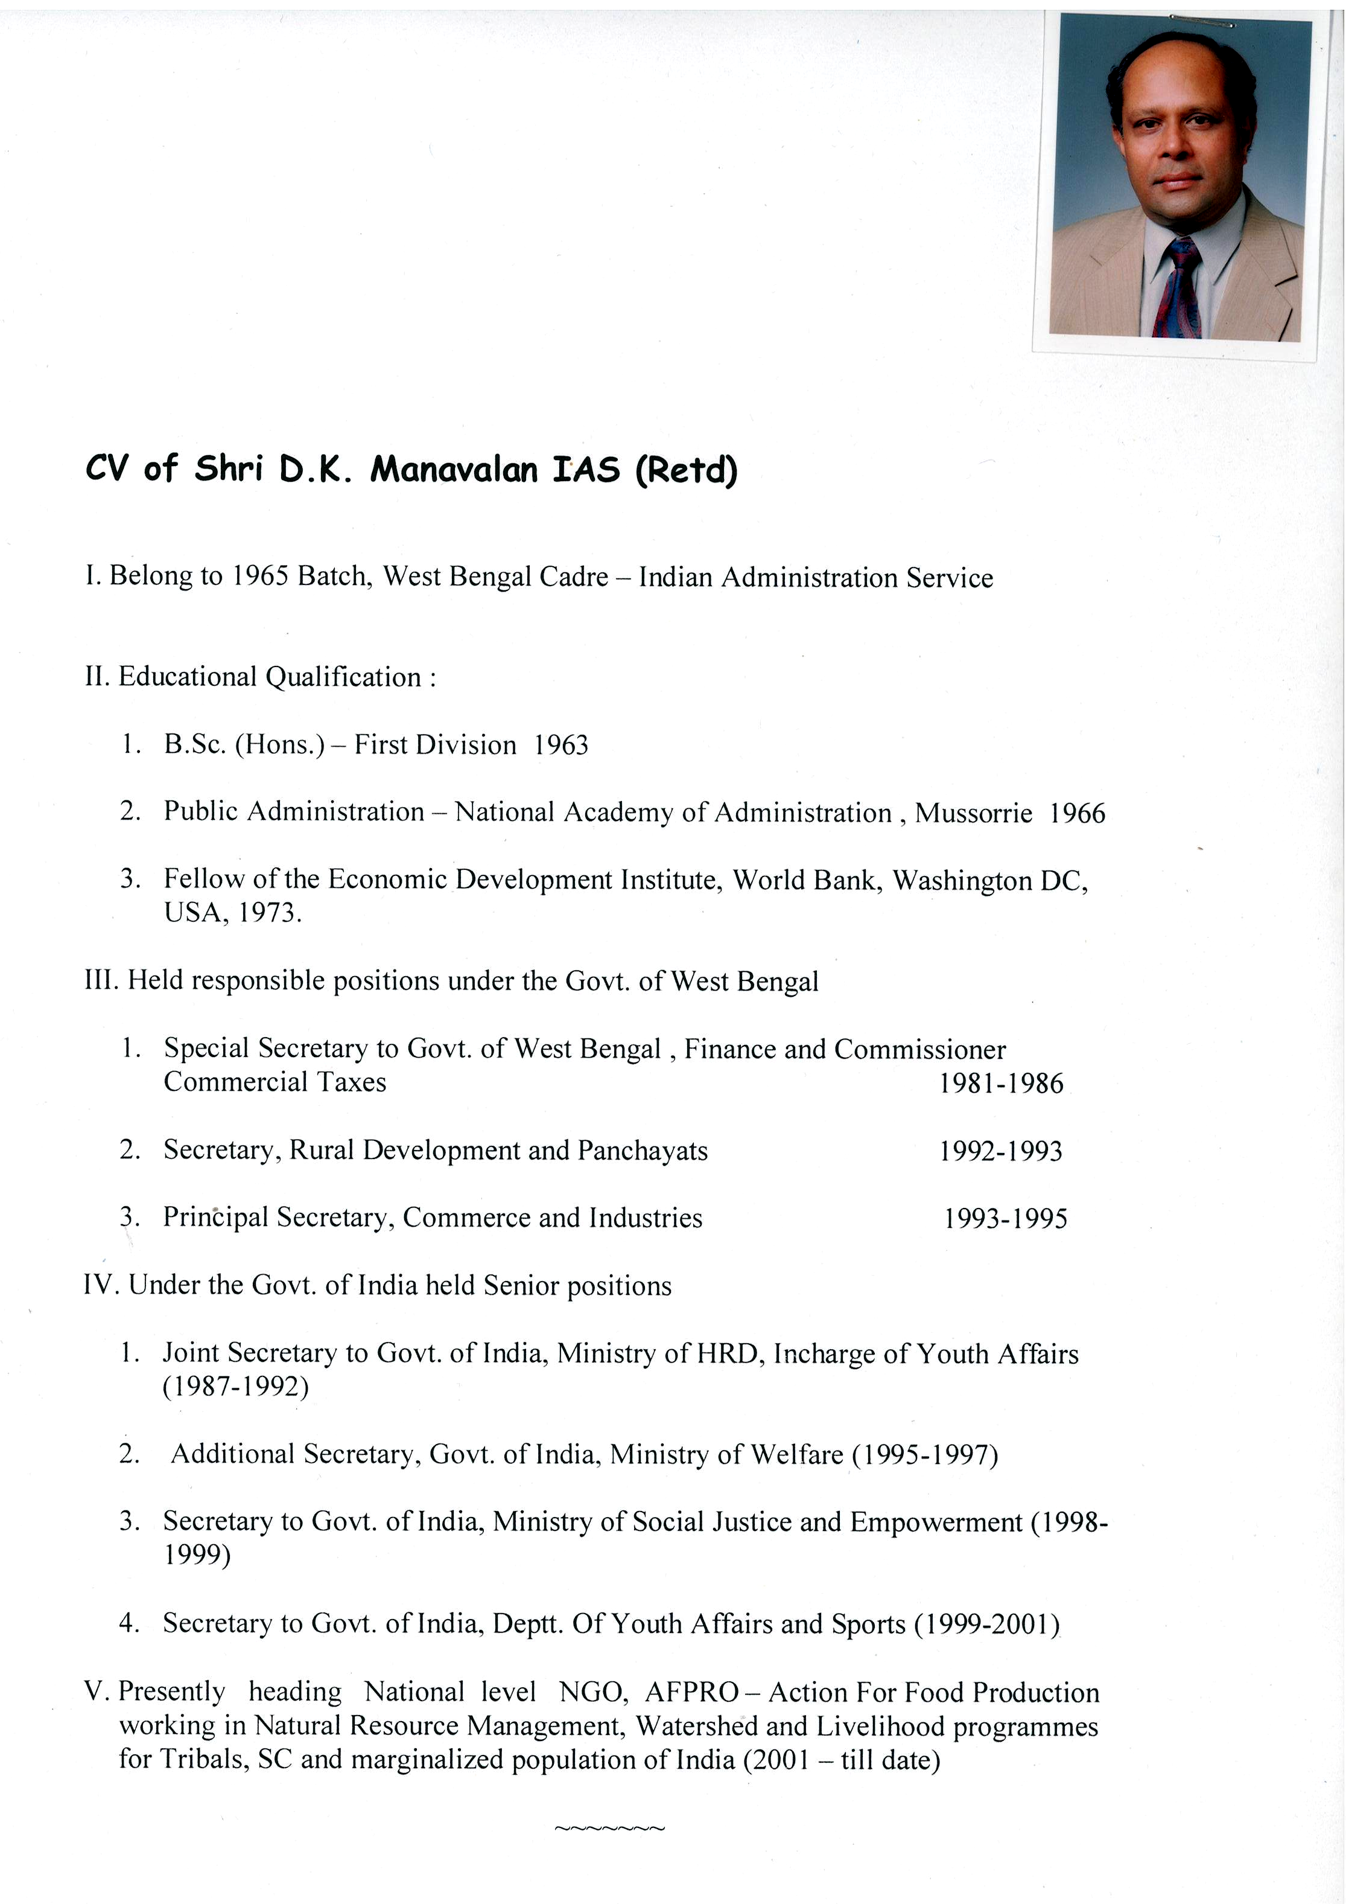
Profile of Shri D.K. Manavalan IAS (Retd

